Ben Zhu

bjz2107

Neural control Engineering

HW3

1a) The system is non linear. Inputting some x0 and x1, with singular output y0 and y1, when inputting x0+x1 does not result in y0+y1. Attempted to test a sin input, and was unclear if the frequency was preserved -> either way, this system is non linear. This was also tested with some constants, and some impulses.

1b) Volterra Kernel is generated on HW3_1.m

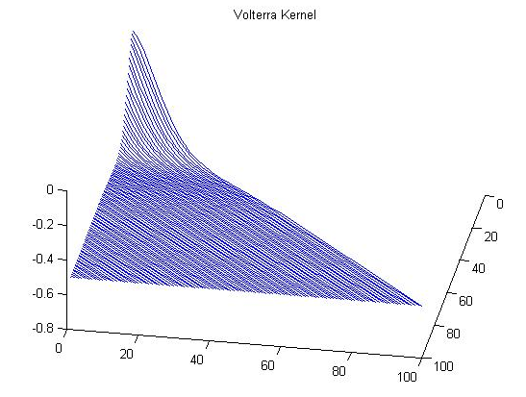

2) I don't know how to actually describe everything,

but the sections of the code do two distinct things. The first part calculates the spike-triggered average images for each of the 12 time steps before each spike, and then shows them via imagesc. The last part is weighted, and summed across one spatial dimension for all the bins.

If the program is run, each of the individual 12 will be displayed. Below is the sum of the figures to reproduce figure 2.25C.

